Approvals – Deployment Guide

1. Solution structure
   1. JSON representation of an Approval workflow

Consider, that every workflow process can be described as a sequence of stages, where each stage contains one or more parallel approval tasks: a fully sequential workflow can be represented as a sequence of stages with one approver each, whereas a fully parallel workflow can be represented as a single stage with multiple approvers.

This structure can be represented in JSON format as follows:

{

“Stages”: [

{

“index”: 0,

Approvers: [

{

“email”: “user1@domain.com”

},

{

“email”: “user2@domain.com”

}

]

},

{

“index”: 1,

Approvers: [

{

“email”: “user3@domain.com”

},

{

“email”: “user4@domain.com”

}

]

}

]

}

Understanding of this concept is key because this approval workflow implementation relies upon it to capture the approval process and be able at every moment to figure out what the next steps should be.

* 1. Approval process





1. “Request approval” flow is triggered manually on a document.

**Note:** The user triggering the flow is presumably the document’s author and will be known henceforth as the approval **Requestor**.

Once triggered, the “Request approval” process then:

1. Creates an **Approval History** record, indicating that a new the approval process has been started.
2. Uses input information to generate **JSON representation of the workflow** process and creates tasks for the first stage of the process.
3. Sends an email to each **approver**, notifying them of the new task assigned to them.

In the meantime, for every task created, another Flow (Approval worker flow) triggers automatically behind the scenes and:

1. “Auto-registers” approvers in the **Approvals Registry** list to make sure they can get access to the correct Approval-enabled sites
2. Updates the task’s “Created by” (a.k.a. “Author”) and “Modified by” (a.k.a. “Editor”) fields to the value of the “Assigned to” field.
3. Makes sure all approvers are listed in the Approvals Registry site.

Both steps are required to make sure that users can efficiently see their own tasks.

Once Approver receives the notification, they:

1. Open **Approvals** Power App (either via M365 UI, or using one of the links in the email notification)
2. Submits their response and any associated comments, which triggers the **Process approver response** flow.
3. Process approver response flow:
   1. Analyzes submitted response
   2. Submits appropriate record(s) to the Approval History list
   3. Determines next steps in the flow based on its current state as well as the provided response.
   4. Creates new task (or tasks) as appropriate.
   5. Sends notifications to the affected/involved users.
   6. (In case of the final task in the flow) Compiles workflow summary and updates Approval Outcome metadata field for the original document.
   7. Approval cancellation

Approval initiators and Approval administrators may cancel running workflow instances. They can do so by logging into the Approvals power app, choosing “Cancel approvals”, selecting the appropriate approval process and choosing to cancel it.

If an approval is cancelled:

* All active tasks for the approval are deleted
* An approval history record is created, indicating that the workflow has been canceled
* A notification is sent to the approval initiator
* The “source” document’s Approval outcome and Approval summary fields are re-set to their previous state

1. Requirements

The solution described here is relying only on Standard Power Platform connectors – and therefore at the time of creation does not require any additional licensing besides Microsoft 365 E3/E5.

At this time, minimal solution requirements are defined as follows:

### Deployment

* Microsoft 365 E3 license or higher
* SharePoint Administrator Role
* Edit-level access to Power Apps and Power Automate

### Execution

* Microsoft 365 E3 license or higher
* The Power Platform Service account must have site collection admin privileges for each site where workflow is running
* May require purchase of additional API calls for the approval process flows

1. Deployment Guide

This section provides a step by step process for deploying the solution in a new environment, as well as for updating an already existing solution.

* 1. Create a Power Platform service account

Various components of the solution will need to run under a site owner-level account. In such case, it is considered good practice to run the flow under a service account (as opposed to having the flow run under a real user’s credentials).

**Note:** you will need to provide licenses for O365 and (potentially) Power Platform to the account.

Create a Power Platform service account on your tenant:

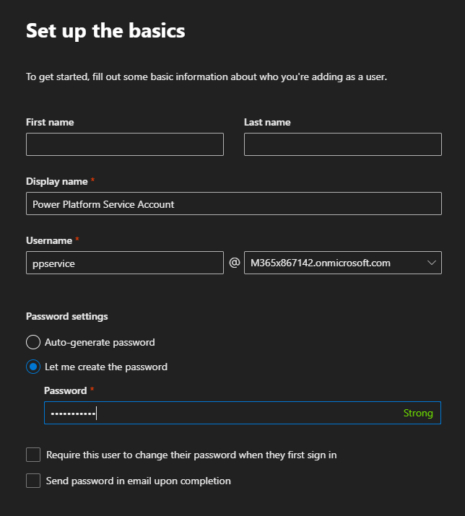

Do not provide any tenant-admin permissions to the account.

Also:

* Make sure the account is licensed in O365 as any regular user in your organization.
* Make sure this account is exempt from any automated password change policies.

**Note:** this account will be henceforth referred to as *ppservice*.

* 1. Configure Approvals Registry site

Configure and run *Create-ApprovalsRegistrySite.ps1* script to create Approvals Registry site. Note that the script will require you to specify the *ppservice* account you created during step 4.1.

The script will grant owner-lever permissions on the Approvals Registry site to this account.  The script will also perform the following actions:

* Grant Read access to site for Everyone except external users
* Create Approvals Registry list with all the required fields
* Create Approval Instances list with all the required fields
  1. Deploy Approval History Clean-up flow

1. Open Power Automate and Import *ApprovalHistoryCleanup-Template.zip* package.

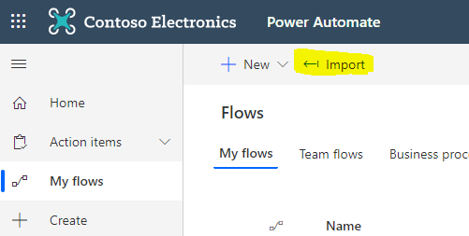

1. During import, select "Create as new" and choose the ppservice account for the SharePoint connection (Create a new SharePoint connection for the *ppservice* account if one does not exist already).

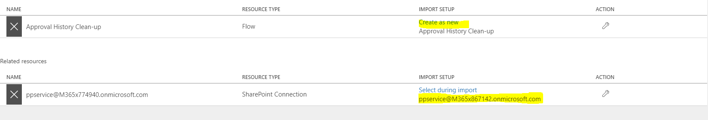

1. Click Import
2. Edit Approval History Clean-up flow and modify variable labeled CONFIG to match your environment:
   1. ApprovalsRegistryUrl – Url of the Approvals Registry site, as per section 4.2 of this document
   2. ApprovalsRegistryListName – this value is set to “Approvals Registry” by default and will likely remain unchanged (unless you have renamed the list in your environment).
   3. ApprovalHistoryListName – this value will also likely remain unchanged, unless you are going to be calling Approval History lists something different
   4. ExpirationAgeDays – after how many days will workflow history records be deleted (default = 60)

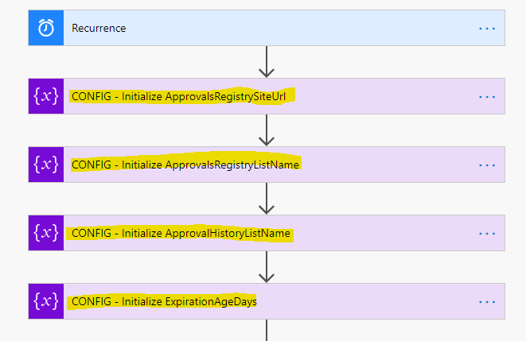

* 1. Deploy Approvals Power App
     1. Import the App package

1. Navigate to PowerApps and click on Apps 🡪 Import canvas app. Select *Approvals-Template.zip*

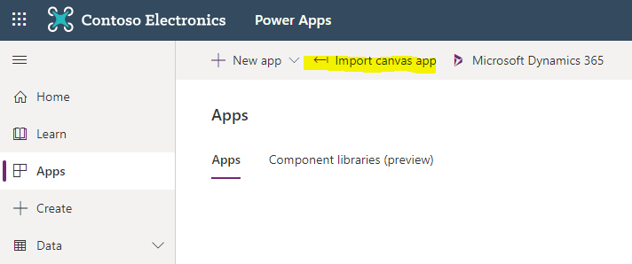

1. On the import package screen, choose *Create as new* for all the components being imported. Specify the *ppservice* account when prompted. Create new connections for the *ppservice* account as needed.

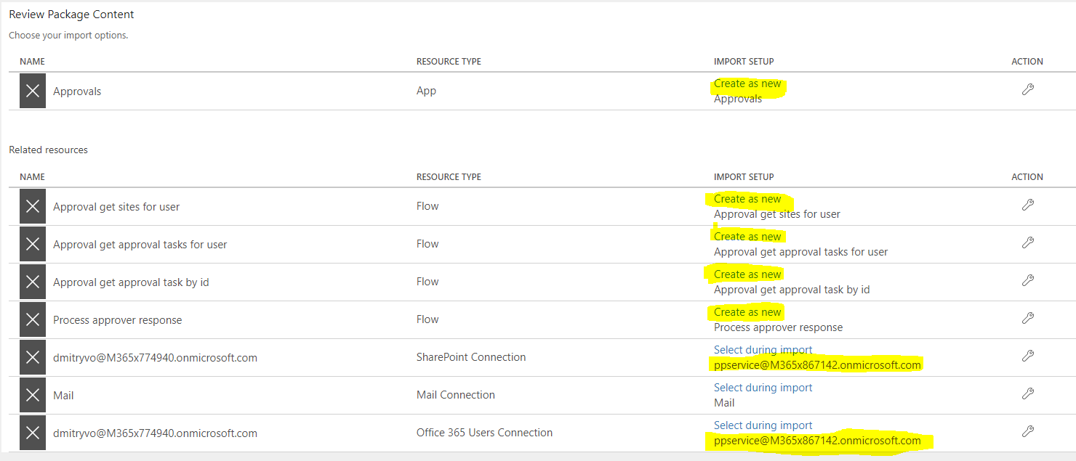

Click *Import.*

**Note:** The *Update* option will be used if deploying a new version of the solution.

1. Share the newly imported app with Everyone or with specific users, as desired. Make sure to designate people you share with as Users (can use the app, but unable to make changes):

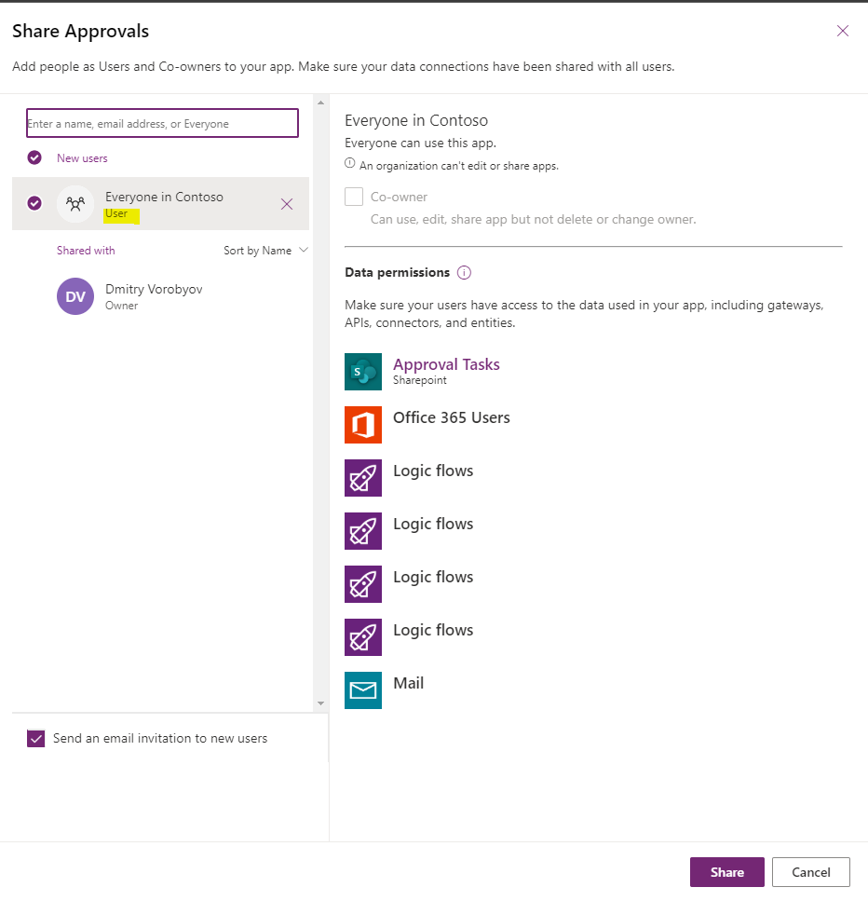

**Note:** pay attention to the *Send an email invitation…* checkbox at the bottom left corner of the screen. You may want to uncheck it if announcing the fact that application has been shared with everyone is not your intention.

1. Once the App has been shared, click *… --> Details* and copy the *AppID* value.

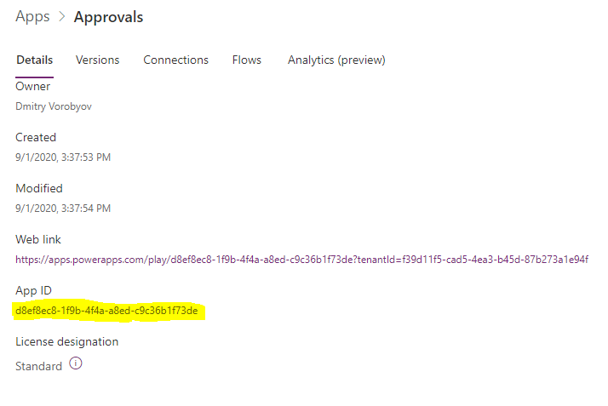

1. Open the Approvals App in edit mode, then select App in the Tree View, choose *On Start* event in the main drop-down and change the formula as follows: *Set(AppId, "app id value from step 4")*

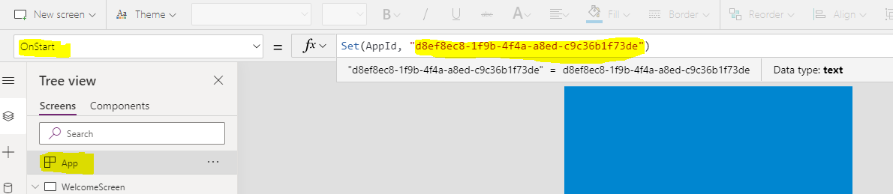

Click *File 🡪 Save* and then *Publish* to make the change available to all users. Close the PowerApps Studio tab.

1. Update *Approval get sites for user* flow
   1. Navigate to Power Automate, edit *Approval get sites for user* flow.
   2. Replace values in the first two steps labeled CONFIG (*ApprovalsRegistrySiteUrl* and *ApprovalsRegistryListName*) as appropriate.

**Note:** since Approvals Registry list name is standard, you should only need to update *ApprovalsRegistrySiteUrl*

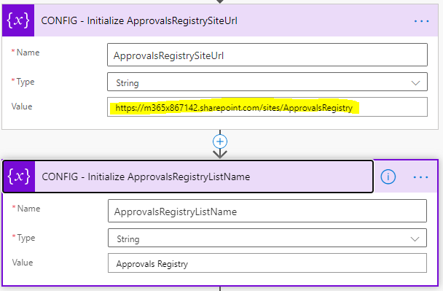

* 1. Save Flow

1. Update *Approval get active approvals for user* flow
   1. Navigate to Power Automate, edit *Approval get active approvals for user* flow.
   2. Replace values in the first four steps labeled CONFIG (*ApprovalsRegistrySiteUrl,* *ApprovalsRegistryListName, ApprovalInstancesListName and ApprovalHistoryListName*) as appropriate.

**Note:** You should only need to update *ApprovalsRegistrySiteUrl*, since all the list names are standard

1. Similarly, update the CONFIG values as needed for the following flows:
   1. *Approval get approval tasks for user*
   2. *Approval cancel approval* flow

**Note:** Steps 4.1 to 4.3 are one-time steps that needs to happen only the first time the solution is deployed to the environment. These steps may need to be revisited only if the solution is updated and requires changes to this side of the setup.

* 1. Deploy site-specific components
     1. Select a site for approvals and configure permissions

Select a site where approvals need to be triggered and grant the Power Platform Service account owner-level permissions.

**Note:** if the site is group-enabled, use "share site only" permissions (i.e. do not add the service account to the M365 group).

* + 1. Configure the “source” site

1. Create a document library (or choose existing) where approval process needs to be triggered from.
2. Configure and run *ConfigureApprovals-SPOLibrary.ps1* script. Specify site URL and selected library’s name in the config values.

The script will do the following:

* 1. Create three fields in the chosen document library:
     1. Approval Outcome (single line of text)
     2. Approval Summary (multiple lines of text)
     3. Previous Approval (multiple lines of text)
  2. Create "Approval Tasks" and "Approval History" lists.

**Note:** the script is designed to skip elements that already exist on the site and therefore can be executed multiple times, if needed to add missing elements.

1. Deploy the trigger flow ("Request approval").
   1. Open Power Automate and Import *RequestApproval-Template.zip* package.



* 1. During import, select "Create as new":

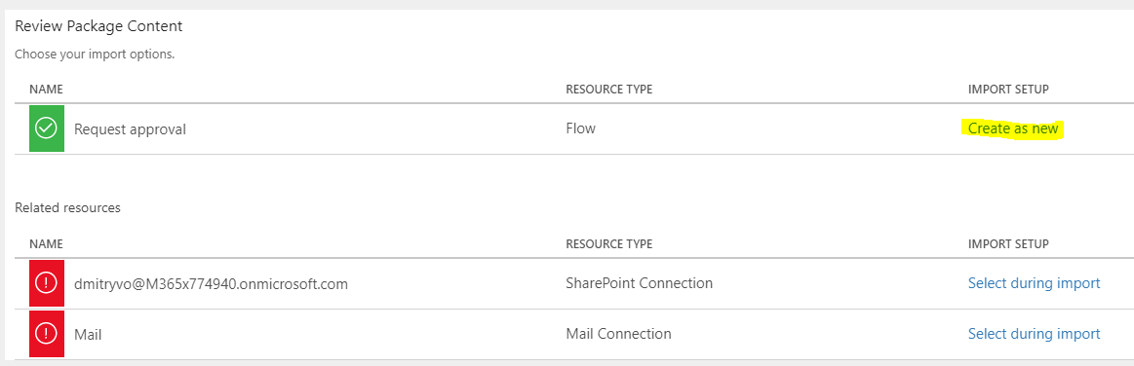

… and provide a different name:

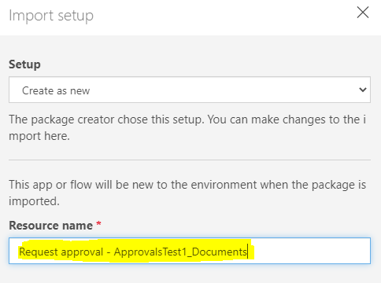

**Note:** keep in mind that you will need a new instance of this flow for every library with approvals, so make sure to give it a library-specific name during deployment (e.g. "Request approval - Site_LibraryName").

Then Click *Save* and proceed to select the *ppservice* credential for all Related resources. Create connections for the ppservice if required.

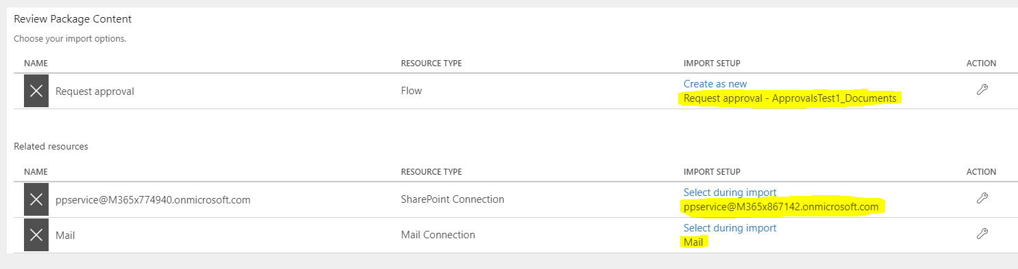

Click *Import* when ready.

* 1. Once the flow has been imported, click "Open flow":

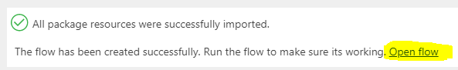

* 1. Expand *For a selected file* trigger and make sure to point it to the correct Site and Document Library:

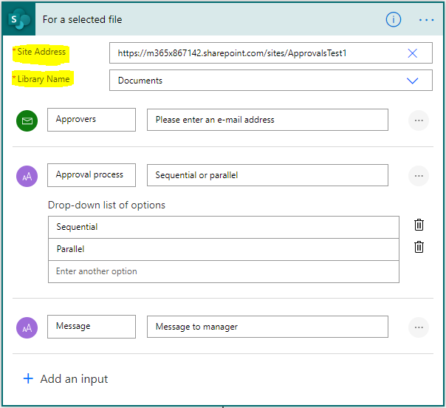

* 1. Expand each of the seven variables marked CONFIG (*ApprovalsRegistrySiteUrl, ApprovalsRegistryListName, ApprovalInstancesListName, SiteUrl, ListName, ListUrl, ApprovalsAppID*)and change the values as appropriate:

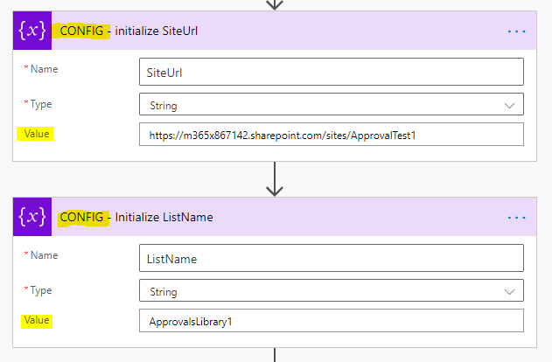

**Note:** use the value from Section 4.3.2.1 – step 5 for the *ApprovalsAppID* value

* 1. Save the flow.
  2. Go back to *My flows*, then click the *Request Approval…* flow title to open its details page and click *Edit* next to the "Run-only users" section.

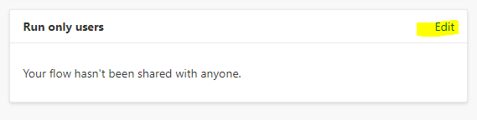  
  
Then select *SharePoint* and configure the correct library as a run-only user for this flow. Make sure to configure SharePoint access to happen under ppservice credentials. Make sure to click *Add* after selecting the library.

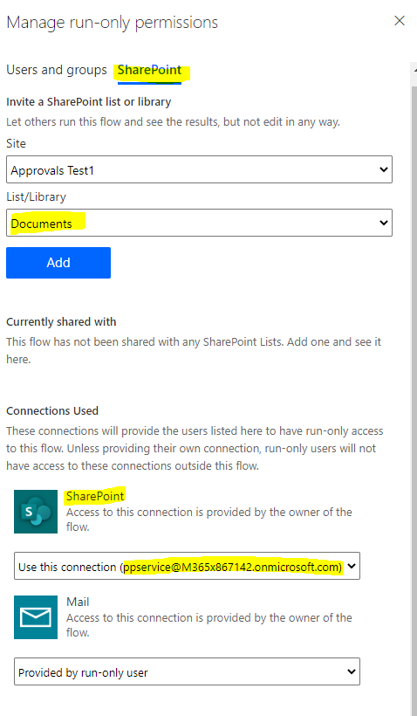

**Note:** keep in mind that you will need a new instance of this flow for every Approval Tasks list (therefore, one per site), so make sure to give it a library-specific name during deployment (e.g. "Request approval - Site").

1. Use the same process to deploy the “Approval worker flow” (*Worker-Template.zip*). This flow will trigger automatically when a new task is created in the Approval Tasks list.

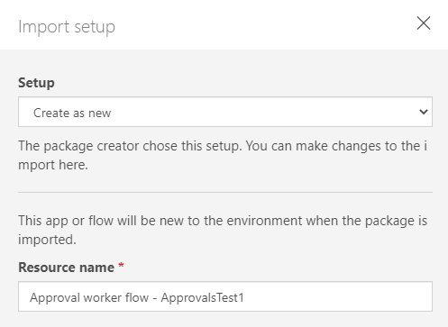

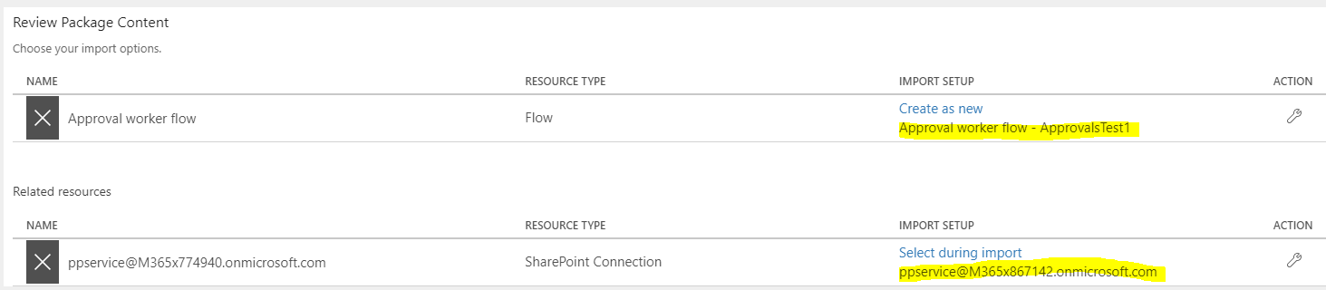

Once the import is completed, click *Open flow,* and:

* 1. Change the trigger step (*When a new item is created*) to point to the **Approval Tasks** list on the correct site.

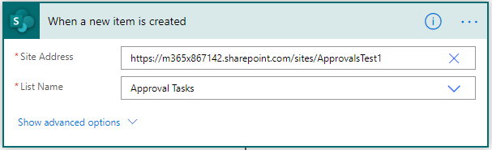

* 1. Update the “CONFIG - Initialize ApprovalsAppID” step to contain the correct id value for the Approvals app (see Section 4.4.1, step 4).

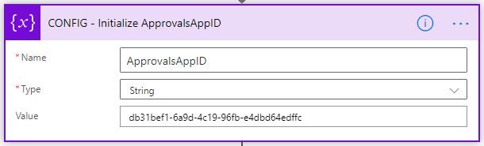

* + 1. Register the site for approvals

Navigate to the Approvals Registry site, open the Approvals Registry list, and add an entry, registering your site for the Approvals process. Specify one or more Administrators s users who will be able to see and complete Approval tasks on behalf of other users.

**Note:**

* Administrators will require Site collection admin permissions.
* Do not add any users to the Approvers column, this column will be updated automatically as users create approval requests.

1. Backlog

This section contains a list of missing features (so far), known issues, etc.

* [Bug][Approval flow] If Submit gets "stuck" an approver can theoretically approve an item twice.   
  Solution: check if history record for approver for current stage already exists before creating one
* [Feature] [Source library] Auto-create approval-related fields: Approval Outcome (rename to Approval Status?), Approval Summary

1. Appendix A. List schema

The tables below contain a schema for the 3 foundational lists that are being relied upon by the Approvals solution.

* + 1. Approvals Registry list

The **Approvals Registry** list resides within the Approvals Registry site and provides a “coordination point” for the Approvals app, acting as a centralized source of information around the level of access users have to different sites and simplifies compiling information in the Approvals app.

**Note:** only one such list is required for an M365 tenant, regardless of the number of sites/lists using the Approvals solution

|  |  |  |
| --- | --- | --- |
| Field Name | Field type | Description |
| Title | Single line of text | OOB Title field. Contains title of an Approval-enabled site. |
| Site Url | Single line of text | Contains URL of an Approval-enabled site |
| Administrators | Person | This field contains a list of users allowed to see and complete other people tasks on their behalf. These users must have Full control permissions on the Approval-enabled site. |
| Approvers | Person | This field contains a list of people who have at some point been assigned as an approver on the Approval-enabled site.  ***Note:*** *this field will be managed automatically by the solution, there is no need to add any values to this field manually* |

* + 1. Approval Instances list

|  |  |  |
| --- | --- | --- |
| Field Name | Field type | Description |
| Title | Single line of text | OOB Title field. Contains title of an Approval-enabled site. |
| SiteUrl | Single line of text | URL of the “host” site for the approval instance |
| Approval GUID | Person | A unique GUID identifier to distinguish tasks belonging to the same approval process |
| User | Person | Approval instance initiator |
| ItemListName | Single line of text | URL of the site, containins the source document |
| ItemID | Single line of text | List item ID of the source document |
| ItemUrl | Single line of text | URL of the source document |
| Status | Single line of text | Status of the running instance (default value is “Active”). Currently not in use. |

* + 1. Approval Tasks list

An instance of the **Approval Tasks** list is required for each Approval-enabled site. Like the SharePoint 2010 Approval workflow, this list contains active tasks for different participants of the approval process.

|  |  |  |
| --- | --- | --- |
| Field Name | Field type | Description |
| Title | Single line of text | OOB Title field, not involved in the process. Set to the document title by default. |
| Assigned To | Person | Contains the name of the person the |
| Description | Single line of text |  |
| ApprovalGUID | Single line of text | A unique GUID identifier to distinguish tasks belonging to the same approval process |
| Link | Hyperlink | Link to the document being approved |
| Stage | Number | Index of the workflow stage currently being process |
| Requested by | Person | Name of the user who requested the task |
| ItemListName | Single line of text | Name of the “source” document library for the document being approved |
| ItemID | Number | List item ID of the document being approved |
| TaskType | Choice | This field could also be a string. It can take values of “Approval” or “Submit changes” to distinguish between two possible types of tasks |
| ItemFileName | Single line of text | File name of the document being approved |
| ItemListUrl | Single line of text | URL of the document library containing the document being approved |
| TasksListName | Single line of text | Name of the Approval Tasks list where the approval tasks are being created. This value can be changed by configuring the solution flows, but it is recommended to leave it as the default value: “Approval Tasks”. |
| HistoryListName | Single line of text | Name of the Approval History list where the approval tasks are being created. This value can be changed by configuring the solution flows, but it is recommended to leave it as the default value: “Approval History”. |
| Status | Single line of text | This field is required to distinguish active tasks from completed tasks that have not yet been deleted from the Tasks list.  Once a user completed a task, this field is immediately set to “Completed” to prevent the task from appearing as available in the Approvals app. |
| ApprovalRegistrySiteUrl | Single line of text | URL of the Approvals Registry site |
| ApprovalRegistryListName | Single line of text | Name of the Approvals Registry list. It is recommended to leave it as the default value: “Approvals Registry”. |
| ApprovalInstancesListName | Single line of text | Name of the Approval Instances list. It is recommended to leave it as the default value: “Approvals Instances”. |
| Created By | Person | This is an OOB field. For each task it will be modified automatically to the same user as the “Assigned To” field. |
| Modified By | Person | This is an OOB field. For each task it will be modified automatically to the same user as the “Assigned To” field. |

* + 1. Approval History list

An instance of the **Approval History** list is required for each Approval-enabled site. Like the SharePoint 2010 Approval workflow, this list contains records of all actions that occurred during the approval process.

|  |  |  |
| --- | --- | --- |
| Field Name | Field type | Description |
| Title | Single line of text | OOB Title field, not involved in the process. Set to the document title by default. |
| ApprovalGUID | Single line of text | A unique GUID identifier to distinguish tasks belonging to the same approval process |
| ItemURL | Hyperlink | Link to the document being approved |
| EventDate | Date and Time | Timestamp for the approval event |
| EventType | Single line of text | Short title of the event that occurred (e.g. Approved, Rejected, etc.) |
| User | Person or Group | User, who performed the action |
| Description | Multiple lines of text | Detailed description of the event |
| Outcome | Single line of text | This value is only set once the approval process completes. Represents the final outcome of the approval. |
| FullJSON | Multiple lines of text | This field contains the original JSON representation of the approval process and is never changed |
| CurrentStateJSON | Multiple lines of text | This field originally contains the JSON representation of the approval process and is being updated during approval to only contain remaining tasks. At the end of each approval process this field should contain an empty JSON array of stages, indicating that all stages in the approval have been completed. |